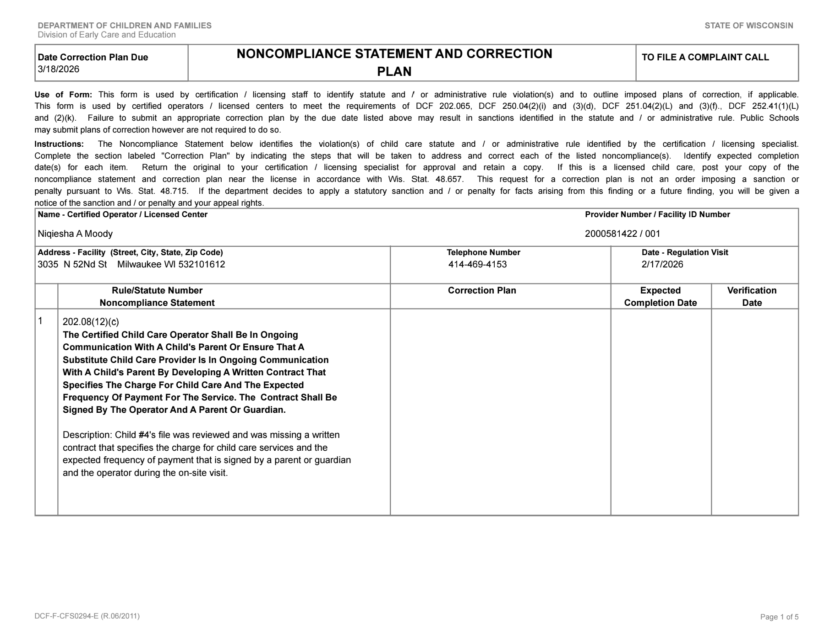
Had parent sign contract &
put it in file.
2/18/26
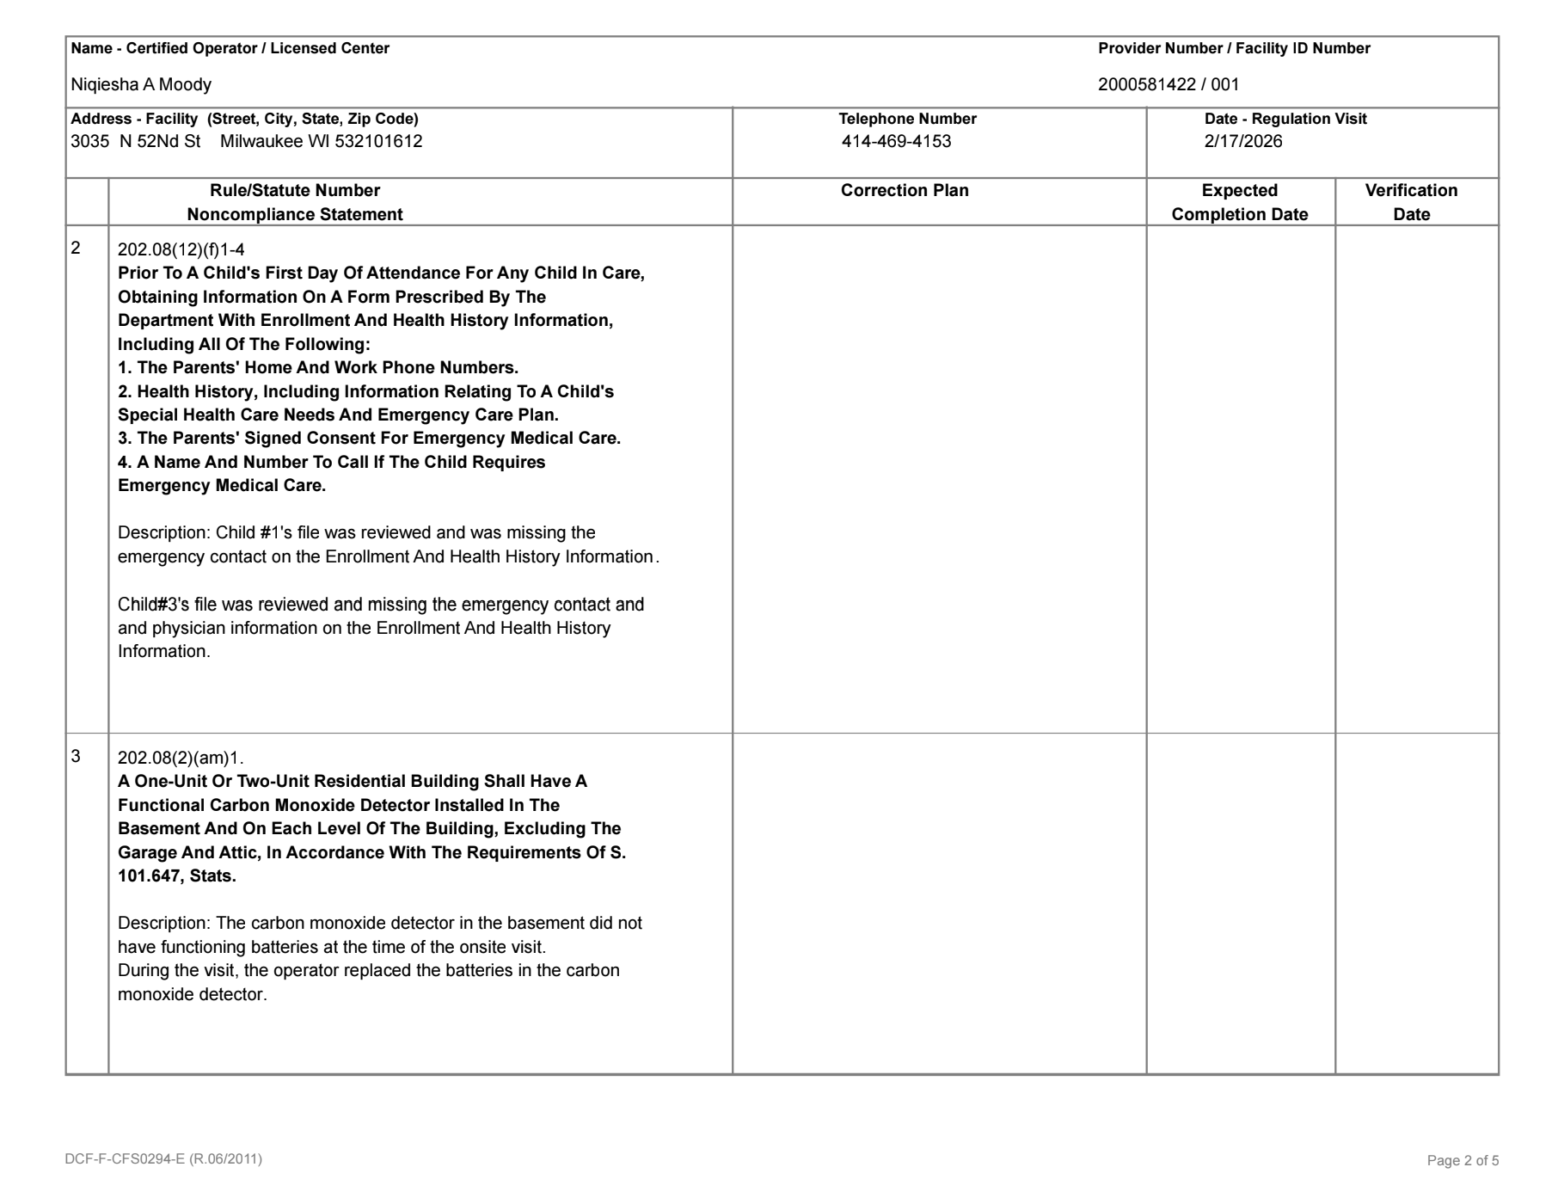
Parents filled out missing
forms and returned to
Center
2/19/26
Batteries were replaced
right away.
2/17/26
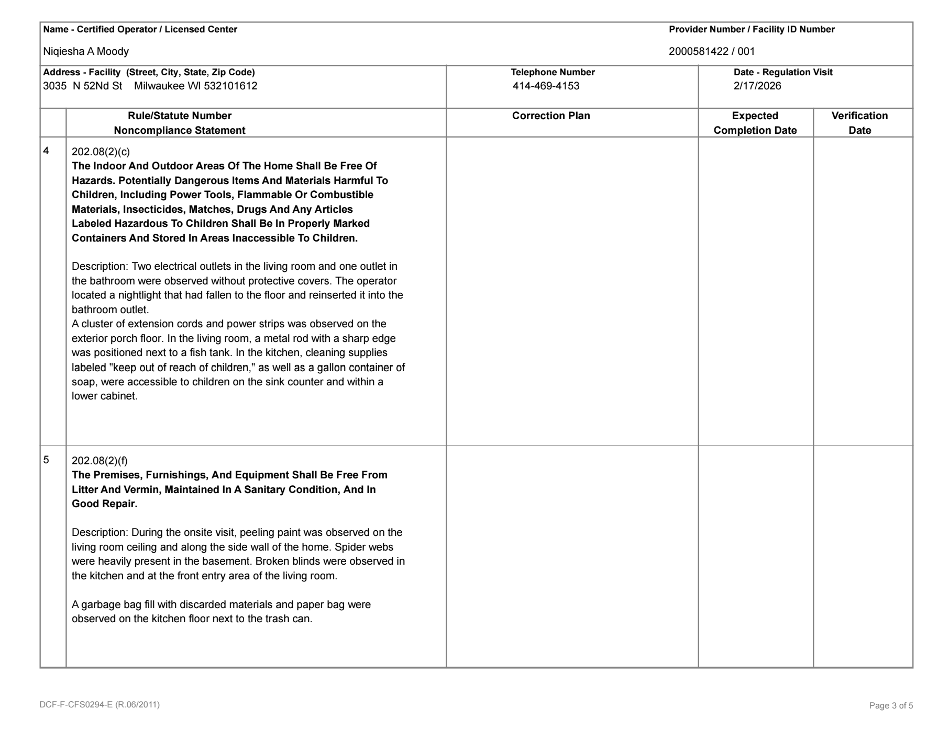
All cords were removed along with dish detergent and
outlets covered
2/17/26
All peeling paint was scraped.
Website swept, blinds fixed.
Bag was taken out.
2/18/26
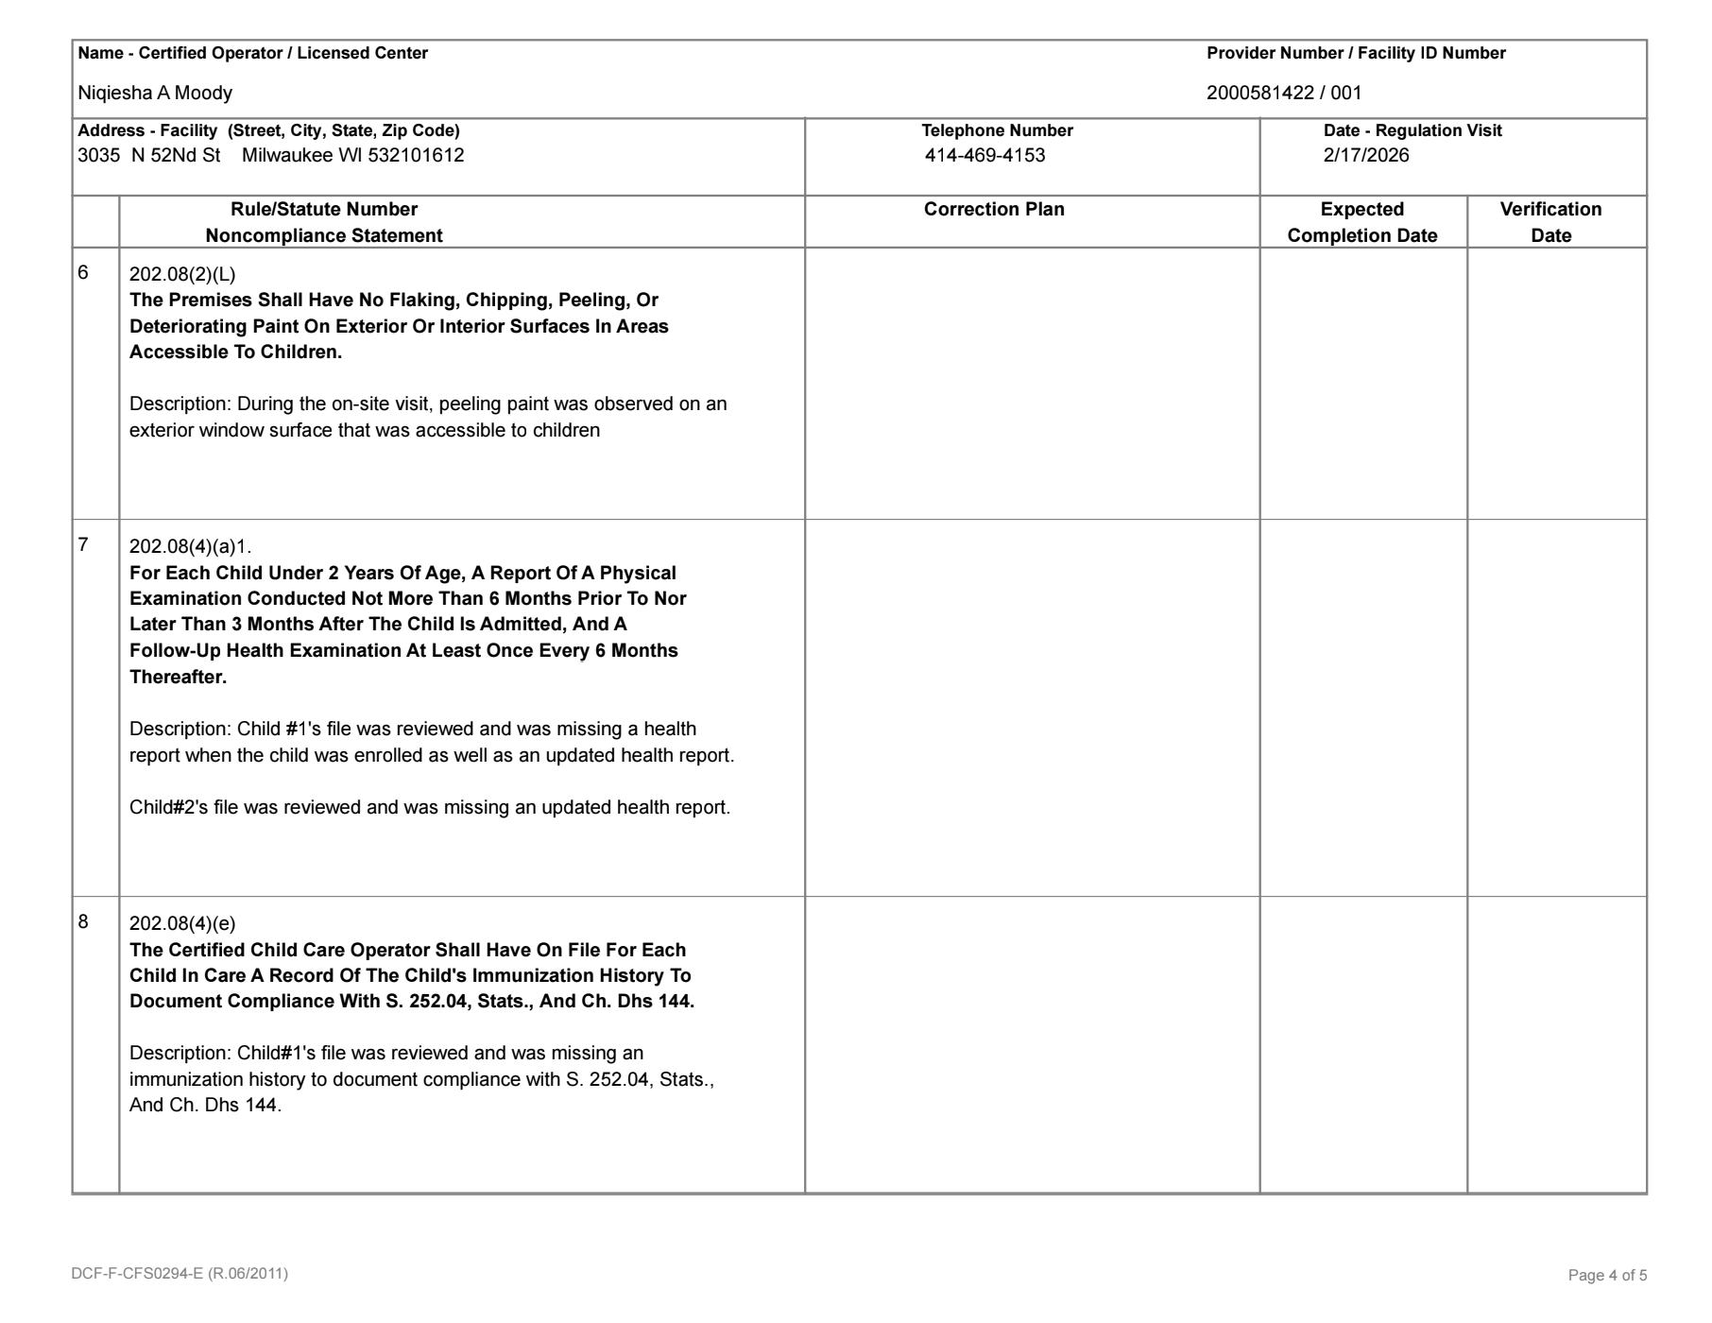
All paint was scraped
and removed.
2/19/26
Appointment was made
With Doctor and health report was updated.
2/23/26
Child's shot records were
printed and put in file
2/23/26
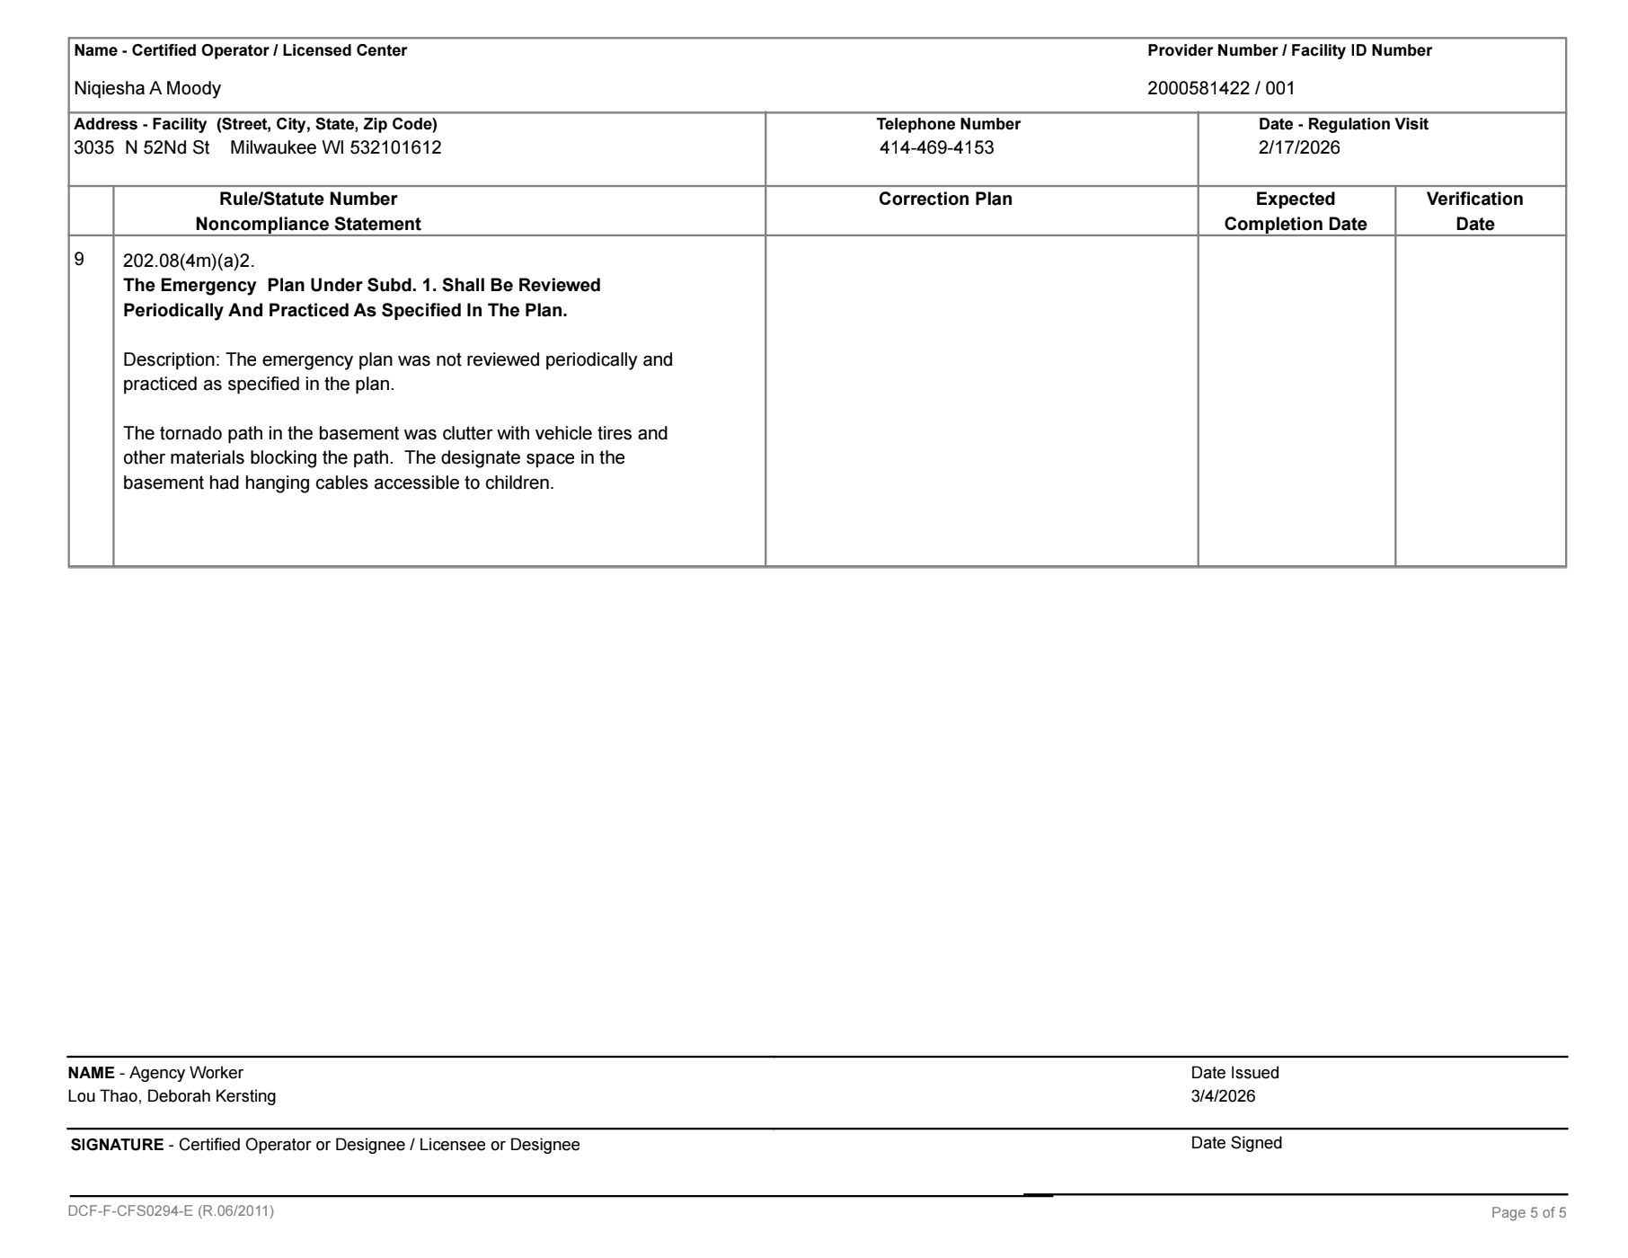
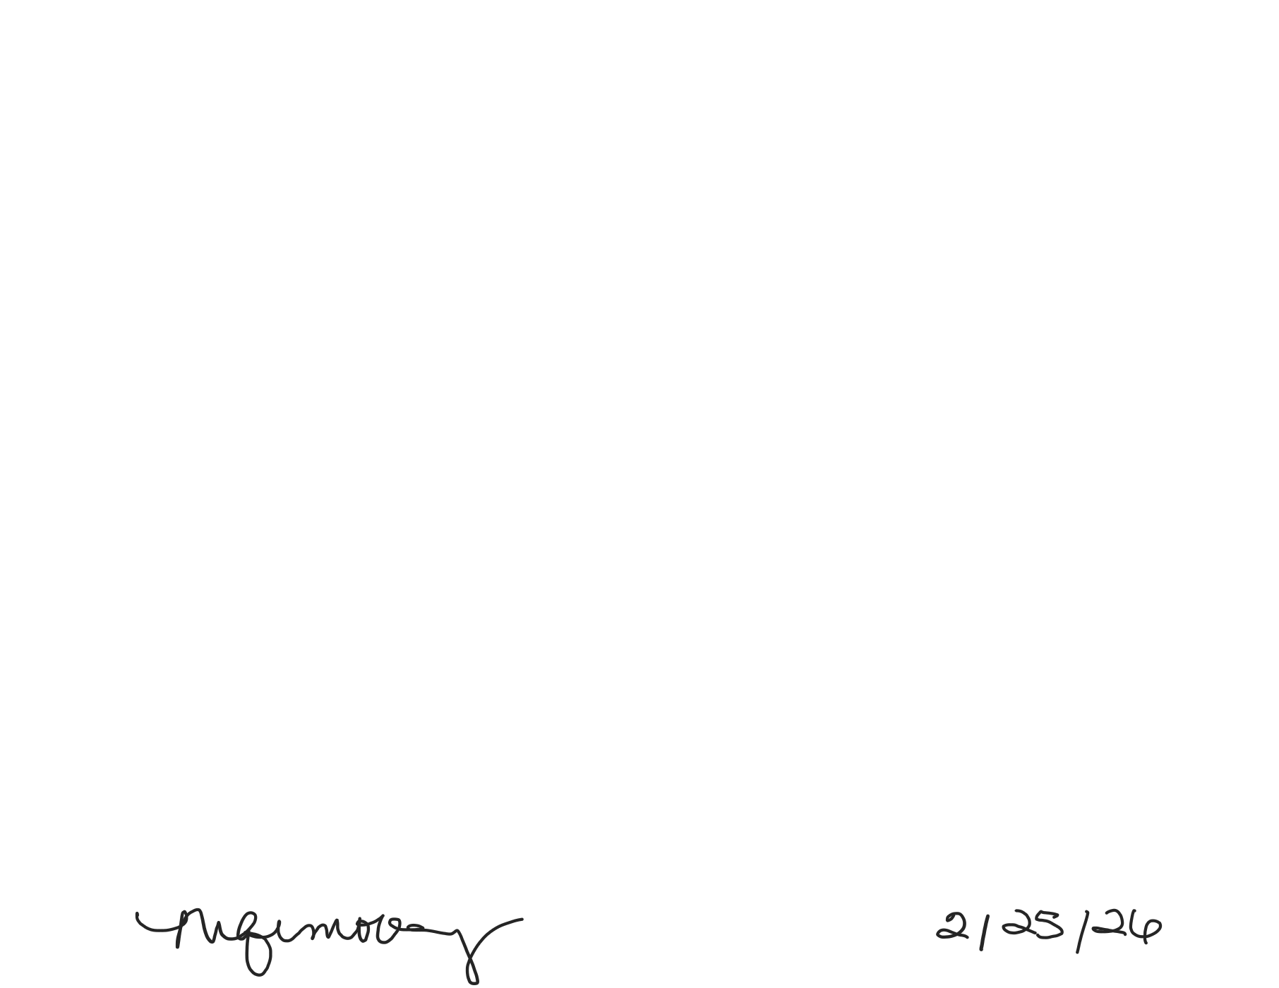
Practiced drills and removed tires from the space for drills. Cords removed.
2/24/26

